**DELHI TECHNOLOGICAL UNIVERSITY**

A PROJECT REPORT ON PARTIAL FULFILLMENT OF

WEB TECHNOLOGIES

“*TryMyDish.com*”



Submitted By

Binoy Panchiwala(2K14/SE/054)

Rachit Gupta(2K14/SE/064)

**ACKNOWLEDGEMENT**

We would like to express our greatest gratitude to the people who have helped and supported us throughout the project.

We are grateful to our parents and teachers for their continuous support for the project, from initial advice to contacts in early stages of conceptual inception and through ongoing advice and encouragement to this day.

We wish to thank them for their undivided support and interest, which inspired and encouraged us to go the right way.

Last but not least, we want to thank our friends who supported and motivated us and also to God who made all things possible.

Binoy Panchiwala(2K14/SE/054)

Rachit Gupta(2K14/SE/064)

**ABSTRACT**

TryMyDish.com is a website for sharing recipes of different dishes by people. The world consists of different regions characterized by different types of cuisines associated with the place of origin. With the advance in technology and sharing of information, a platform for sharing the recipes of different kinds of dishes belonging to different regions seems a vital necessity for the people who are into knowing the dishes available across the world.

This website has been designed and developed solely for the above mentioned purpose. It resembles a social networking website but with a twist- here people are to share their recipes by uploading them onto the server from where they can be accessed anytime, anywhere.

The website allows people to create their own accounts using their email and their own chosen password, and using these as keys to enter their profiles. The profile is a place where they can share personal information about themselves ranging from their address to the cuisines in which they are interested.

Cuisines are classified based on their location of origin, for example, Oriental, Chinese, Mexican, Italian, Indian, etc. This classification makes it easier for people to search for and browse through the dishes of their likes and choices.

The website allows people to follow people of their choice. This facility lets them kept abreast of the latest updates and uploads from the people who share the same mentality towards food as them. Moreover, the individual cuisines can be kept as favourites for them. Furthermore, section for comments has also been added so as to increase the height of socialization among the foodlovers.

**LANGUAGES**

Front End Development:-

HTML & CSS

Front End Development has been done through HTML and CSS.

Hyper Text Markup Language, commonly abbreviated as HTML, is the standard markup language used to create web pages. Along with CSS, and JavaScript, HTML is a cornerstone technology used to create web pages, as well as to create user interfaces for mobile and web applications. Web browsers can read HTML files and render them into visible or audible web pages. HTML describes the structure of a website semantically and, before the advent of Cascading Style Sheets (CSS), included cues for the presentation or appearance of the document (web page), making it a markup language, rather than a programming language.

HTML elements form the building blocks of HTML pages. HTML allows images and other objects to be embedded and it can be used to create interactive forms. It provides a means to create structured documents by denoting structural semantics for text such as headings, paragraphs, lists, links, quotes and other items. HTML elements are delineated by tags, written using angle brackets. Tags such as <img /> and <input /> introduce content into the page directly. Others such as <p>...</p> surround and provide information about document text and may include other tags as sub-elements. Browsers do not display the HTML tags, but use them to interpret the content of the page.

HTML can embed scripts written in languages such as JavaScript which affect the behavior of HTML web pages. HTML markup can also refer the browser to Cascading Style Sheets (CSS) to define the look and layout of text and other material. The World Wide Web Consortium (W3C), maintainer of both the HTML and the CSS standards, has encouraged the use of CSS over explicit presentational HTML since 1997.

Back End Development:-

PHP

Back end development of this website has been done through php where a database has been created in the server to store all the relevant information and entries in the website.

PHP is a server-side scripting language designed for web development but also used as a general-purpose programming language. Originally created by Rasmus Lerdorf in 1994, the PHP reference implementation is now produced by The PHP Group. PHP originally stood for Personal Home Page, but it now stands for the recursive backronym PHP: Hypertext Preprocessor.

PHP code may be embedded into HTML code, or it can be used in combination with various web template systems, web content management system and web frameworks. PHP code is usually processed by a PHP interpreter implemented as a module in the web server or as a Common Gateway Interface (CGI) executable. The web server combines the results of the interpreted and executed PHP code, which may be any type of data, including images, with the generated web page. PHP code may also be executed with a command-line interface (CLI) and can be used to implement standalone graphical applications.

The standard PHP interpreter, powered by the Zend Engine, is free software released under the PHP License. PHP has been widely ported and can be deployed on most web servers on almost every operating system and platform, free of charge.

The PHP language evolved without a written formal specification or standard until 2014, leaving the canonical PHP interpreter as a de facto standard. Since 2014 work has gone on to create a formal PHP specification.

During the 2010s there have been increased efforts towards standardisation and code sharing in PHP applications by projects such as PHP-FIG in the form of PSR-initiatives as well as Composer dependency manager and the Packagist repository.

**SNAPSHOTS OF PAGES WITH EXPLANATION**

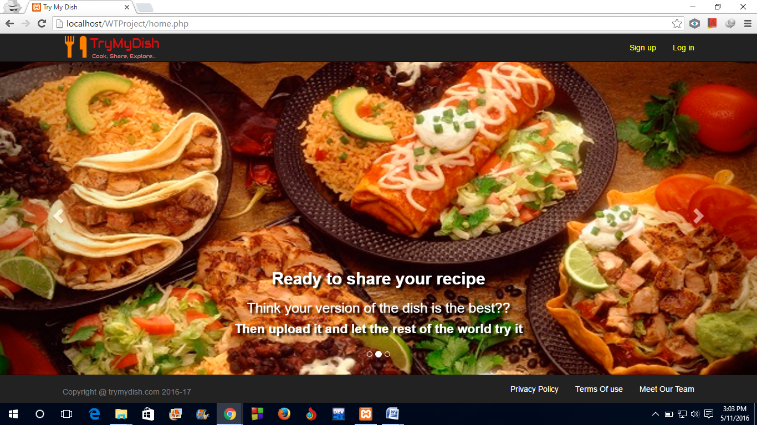

Above is the home page of the website. This has a sign up and a login button on the top right. Sign up is used for new users who wish to establish a profile in the website. Login in used for users who have already signed up for the website. The front page uses carousel effect which can be realized by clicking the white arrows( pointed left/right) towards the left/right margin. This effect is used to realize sliding of images to the left/right side by clicking on the above mentioned arrows.

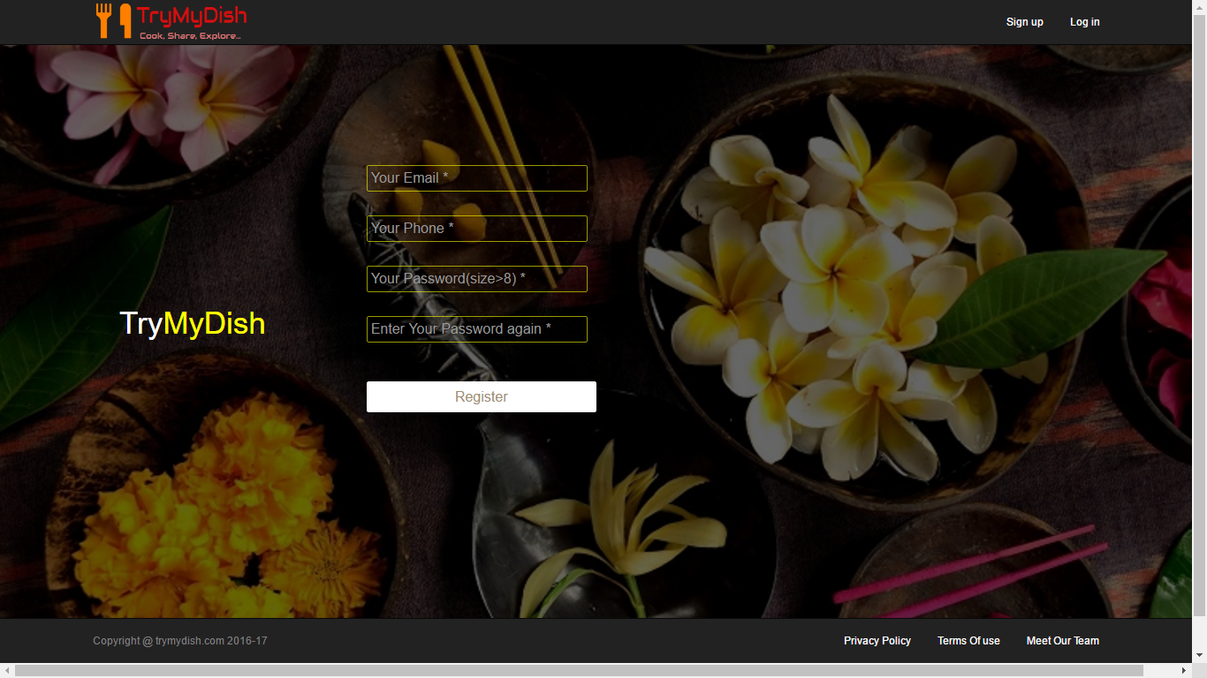

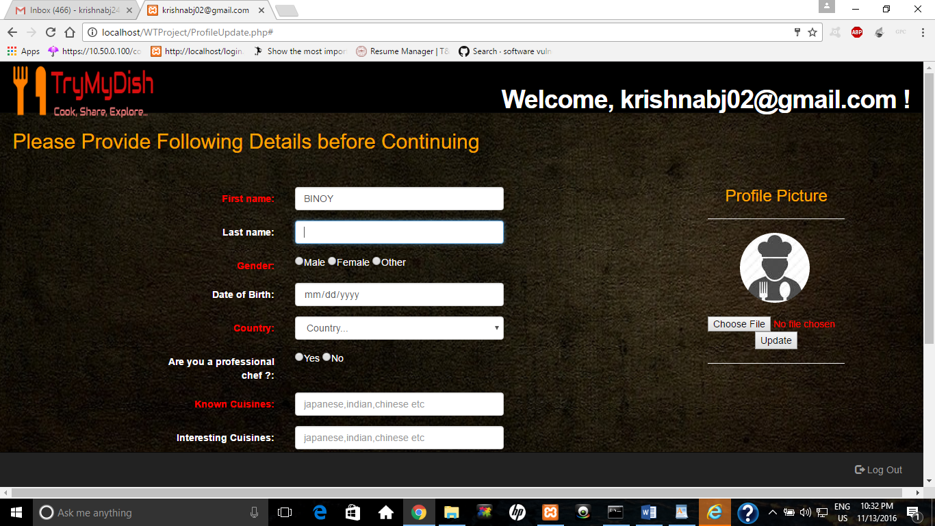

The above page shown is the Sign Up page, shown when we click on the Sign up button on the top right. Signing up requires 4 fields to be filled- Email, Phone number, Password and Confirmation Password.

The information regarding the self can be filled once the account is created and we are diverted to the profile updating page.

In the profile, profile photo can be uploaded.

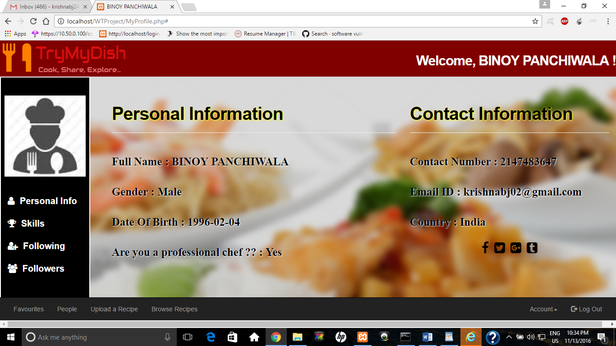

The above page shows the main Profile page which shows personal information of the user. The followers as well the people who the user is following can be seen by clicking the corresponding links of the left side as shown.

In order to upload a recipe, the button “Upload a Recipe” can be clicked, the details of the dish entered and once done, it could be uploaded for the rest of the world to see.

If one wishes to browse a recipe of his/her choice, the link “Browse Recipes” can be clicked which would forward the page to list of uploaded recipes.

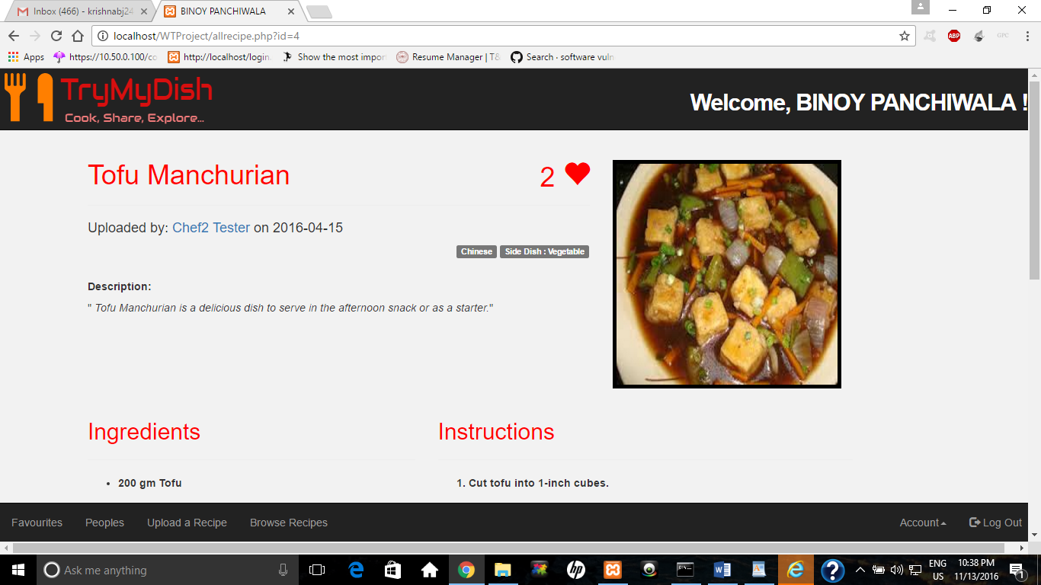

The above page is the page directed to after clicking on the Browse Recipes button. This contains the list of recipes uploaded by the users.

One can add a recipe he/she likes to the Favourites section by clicking on the “Add to Favourites” button shown by the heart symbol. A dish that has been added to favourites, can also be removed by clicking on the same button again.

To learn more about the recipe- the ingredients, the cooking procedure, etc., the link on the recipe could be clicked which would direct to the page showing the whole details about that particular dish.

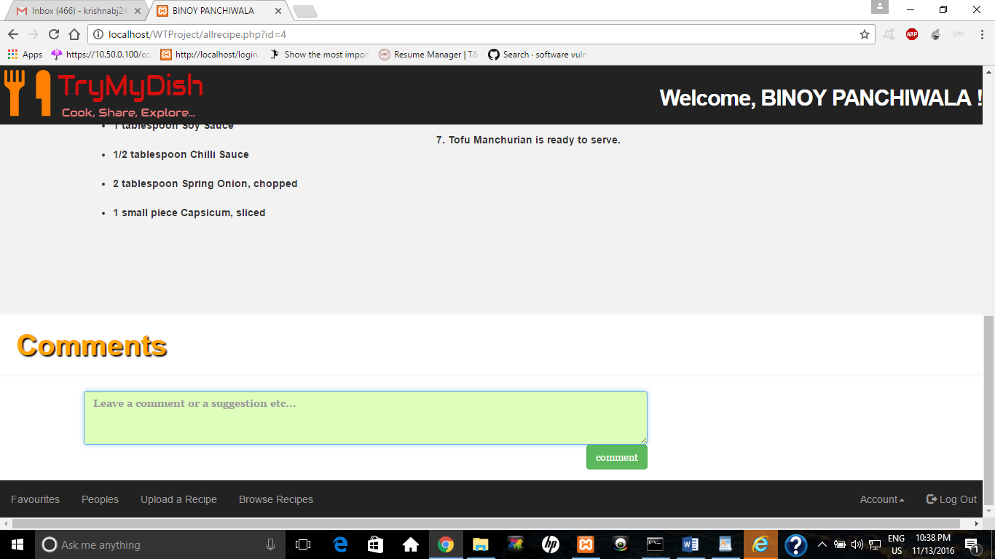

The page shows the details of a particular recipe. This contains the ingredients and the cooking procedure. A separate section for comments has also been added so that users could comment on the dish and in case of doubts, post his/her query.